1. **Agenda**:
   1. What is **SonarQube**?
   2. What are the advantages of **SonarQube**?
   3. How to setup **SonarQube**?
2. To understand SonarQube better, let’s jump into the **Development Phase**.
3. **Development Phase**:
   1. Once a developer writes the code, needs to check if they have written **Quality Code** or not.
   2. **Quality Code** means:
      1. Is it **bug free** or not?
      2. Is it **secure** or not?
         1. Secure means that it is not exposed to any **secure vulnerabilities or problems**.
      3. **Duplication** is avoided.
      4. **Tested Properly**.
      5. **Complex Code**: It is complex, then difficult to understand for a developer or when some problem arises, will take longer time, or may lead to confusion.
      6. **Easy to integrate with others code**: It means that maybe you’re working with other people in your team and during integration, your code should not create any problem.
      7. **Apart** from this, you can do some **other checks to validate your code quality**.
4. But who will check all this for Quality Code?
   1. This is where **Peer Review** comes into picture.
   2. Maybe you ask your colleague who is good in coding and he will suggest some of the betterments to your code.
   3. If code is **lengthy programs** then **reviewing** is a **tedious** task.
   4. **Solution**: Automation which will **review Code Quality**.  
      That is where **Static Code Analysis** comes into the picture.
5. Using Static Code Analysis Benefits:
   1. Helps to improve the code quality.
   2. Reduces time effort (Manual Code Analysis Time)
6. **Static Code Analysis** Tools available in the market.
   1. 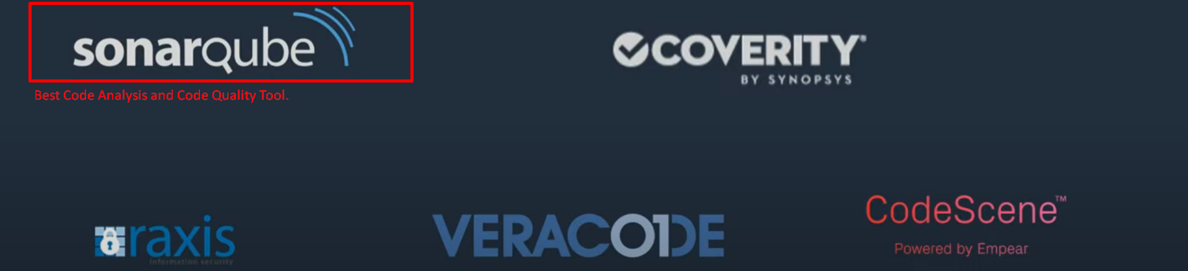
7. **Advantages of SonarQube over other Code Analysis Too (CodeScene etc)**:
   1. It is “Quality Management Tool”.
   2. Why called management tool?
   3. As apart from Code Coverage, it also gathers the reports such as Junit Testing reports or Code Coverage Reports and displays in GUI in very understandable format.  
      
8. **Components of SonarQube**:
   1. **SonarQube Server: 3 Components**
      1. **Rules**:
         1. Instructions which you need to follow when writing code.   
            There are some **best practices** which are converted into **rules**.
         2. There are some default rules which come when installing SonarQube.
      2. **Data**: